Australian National Contact Point
for the OECD Guidelines for Multinational Enterprises

Improving specific instance procedures
Published 22 May 2018

© Commonwealth of Australia 2018
This publication is available for your use under a Creative Commons Attribution 3.0 Australia licence, with the exception of the Commonwealth Coat of Arms, the Treasury logo, photographs, images, signatures and where otherwise stated. The full licence terms are available from http://creativecommons.org/licenses/by/3.0/au/
legalcode.
Use of Treasury material under a Creative Commons Attribution 3.0 Australia licence requires you to attribute the work (but not in any way that suggests that the Treasury endorses you or your use of the work).
Treasury material used ‘as supplied’.
Provided you have not modified or transformed Treasury material in any way including, for example, by changing the Treasury text; calculating percentage changes; graphing or charting data; or deriving new statistics from published Treasury statistics — then Treasury prefers the following attribution:
Source: The Australian Government the Treasury
Derivative material
If you have modified or transformed Treasury material, or derived new material from those of the Treasury in any way, then Treasury prefers the following attribution:
Based on The Australian Government the Treasury data
Use of the Coat of Arms
The terms under which the Coat of Arms can be used are set out on the Department of the Prime Minister and Cabinet website (see www.pmc.gov.au/government/commonwealth-coat-arms).
Other uses
Enquiries regarding this licence and any other use of this document are welcome at:
Manager
Editorial, Media and Speeches Unit
The Treasury
Langton Crescent
Parkes ACT 2600
Email: medialiaison@treasury.gov.au

Contents
Contents ii
Consultation Process 1
Request for feedback 1
Closing date for submissions: 08 June 2018 1
IMPROVING specific instance procedures 2
Introduction 2
Background 2
The AusNCP role and responsibilities 2
The Oversight Committee 3
Specific instances 3
Methodology 4
Proposed Procedures 5
Initial assessment 5
Good offices 6
Conclusion 7
Follow up processes and specific instance review mechanism 8
General operating principles 9
Milestones and timeframes 9
Communication 10
Summary of consultation questions 12
Appendix A — AusNCP specific instance procedures flowchart 13

Consultation Process

Request for feedback
Interested parties are invited to comment on the issues and proposals raised in this paper by 8 June 2018.
Submissions should be lodged electronically.
The principles outlined in this paper are a guide as to how the procedures might operate. Treasury will consider feedback from interested parties and publish updated procedures on the AusNCP website (www.AusNCP.gov.au) after the consultation period concludes.

Closing date for submissions: 08 June 2018
Email: | ANCP@treasury.gov.au
Enquiries: | Enquiries can be directed to Antony Purwono.
Phone: | 02 6263 3777

IMPROVING specific instance procedures

Introduction
Through this discussion paper, Treasury invites stakeholder views on proposed changes to the Australian National Contact Point (AusNCP) specific instance procedures. The specific instance procedures have not changed in the last four years. In 2017, Treasury commissioned an Independent Review (2017 Review) of the AusNCP, which recommended the ‘development and implementation of revised operating procedures based directly on the Guidelines and Procedural Guidance’.
The 2017 Review dealt with a number of matters currently under consideration. Treasury considers it important to review and improve AusNCP procedures, in part to address elements of the 2017 Review, but also to ensure that necessary procedural changes are not delayed while broader issues associated with the review are fully considered. A further revision of the procedures may be undertaken if broader reforms are made to the AusNCP in the future.
The purpose of this discussion paper is to propose changes to the AusNCP’s specific instance procedures to improve case handling and increase efficiency and transparency. Treasury welcomes comments on the proposed changes and seeks the support of stakeholders to deliver lasting improvements. To assist in understanding the specific instance process, a flowchart illustrating the proposed procedures is available at Appendix A.

Background

The AusNCP role and responsibilities
As an OECD member, Australia is an adherent to the OECD Declaration on International Investment and Multinational Enterprises. Each adherent country is required to have a National Contact Point (NCP). Their two main functions are to promote the OECD Guidelines for Multinational Enterprises (the Guidelines) and to consider specific instance complaints about the conduct of multinational enterprises operating in or from countries adhering to the Guidelines. The Guidelines provide recommendations from government to multinational enterprises (MNEs) on responsible business conduct (RBC).
The AusNCP role is currently performed by an individual decision-maker—a senior executive in the Treasury—supported by a small secretariat. In addition to the core NCP functions, the AusNCP also provides advice and assistance to other NCPs; handles all interactions with the OECD NCP Secretariat and Working Party for RBC and provides input to other Australian Government agencies on matters relating to NCP work.

The Oversight Committee
The AusNCP is also supported by an Oversight Committee which provides advice and assistance, particularly in relation to the handling of complaints and identifying opportunities for promotion. The Oversight Committee does not have a decision making role in handling specific instances, but contributes advice and guidance on matters within their area of expertise. The Oversight Committee currently has the ability to review the procedural aspects of a specific instance and make recommendations to the AusNCP.
The 2017 Review identified several areas for improvement in the current function of the Oversight Committee. In particular, the reviewer noted that there is no external visibility of the Oversight Committee’s work and therefore no transparency. The reviewer also expressed concern that the current model allows the AusNCP to serve as the Chair of the Oversight Committee, thereby compromising the committee’s ability to perform a true oversight role that includes monitoring effective performance.
Treasury is considering the structure of the AusNCP, including the role of the Oversight Committee, as part of its broader consideration of the 2017 Review recommendations. Until this consideration is finalised, the Treasury proposes that, in line with current practices, the role of the Oversight Committee in relation to the handling of specific instances will be advisory only.

Specific instances
Specific instances are complaints brought forward by individuals or civil society representatives against MNEs for alleged breaches of the Guidelines. Specific instances are not legal cases. NCPs are non-judicial bodies and have no legislated powers to compel evidence, cooperation from parties or award compensation. NCPs focus on problem solving through dialogue: they offer ‘good offices’ by facilitating access to consensual and non-adversarial conciliation (or mediation). Since its inception in 2001, the AusNCP has handled 17 specific instances, eight of those in the last five years.
The AusNCP’s current procedures for handling specific instances are available on the AusNCP’s website.

Methodology
In preparing these revised procedures, Treasury has taken into account the expectations, recommendations and views presented in the OECD Guidelines, NCP Mediation Manual and 2017 Review.

OECD Guidelines
The OECD Guidelines include implementation procedures and associated commentary which guide all NCPs in their handling of specific instances. They include core criteria within which NCPs should strive to operate; visibility, accessibility, transparency and accountability as well as guiding principles for handling specific instances; impartiality, predictability, equitability and compatibility with the principles and standards of the Guidelines.

NCP Mediation Manual
The NCP Mediation Manual provides practical advice to NCPs on all stages of the specific instance process. The main focus of the manual is to clarify if, when and how NCPs could use mediation and other formal tools to resolve grievances. The NCP Mediation Manual was prepared by the Consensus Building Institute and sponsored by the NCPs of the Netherlands, Norway and the United Kingdom.

2017 Review
In 2017, the Treasury commissioned an independent review of the AusNCP function which was conducted by Ms Alex Newton. Review recommendation three stated that the AusNCP should ‘develop and implement revised operating procedures based directly on the Guidelines and Procedural Guidance.’ A copy of the full report and recommendations is available on the AusNCP website.
As noted above, this discussion paper does not address other recommendations raised in the 2017 Review report. Although any future changes to the AusNCP model are likely to lead to further changes to the procedures, Treasury considers there is a case for improvements to the procedures now, irrespective of potential future changes.

Proposed Procedures
The AusNCP is considering changes to each stage of the specific instance process. The procedures will be rewritten in their entirety and will bring all of its components (e.g. including confidentiality) together to give greater clarity to all parties involved in a case.

Initial assessment
The initial assessment stage determines whether a specific instance complaint merits further examination. Currently, the AusNCP makes an initial assessment on whether to accept a specific instance based on criteria outlined in Box 1. In practice, the application of these criteria has resulted in a prolonged initial assessment stage. The following proposed changes seek to clarify and simplify the process.
Box 1: Current Initial Assessment Criteria
- In making its initial assessment of a specific instance, the AusNCP will consider the stated grounds of the complaint and the information it has received about the complaint, in order to decide:
20.1 whether it falls within one or more of the Guidelines;
20.2. whether the issue raised is material and substantiated; and
20.3. whether there are any other factors which should be taken into account such as, but not limited to:
20.3.1. the relevance of applicable law and procedures, including court rulings;
20.3.2. how similar issues have been, or are being, treated in other domestic or international Specific Instances;
20.3.3. whether consideration of the specific instance would contribute to the purposes and effectiveness of the Guidelines.
To increase transparency around the AusNCP’s actions following receipt of a complaint, the proposed procedures will detail that the complaint submission will undergo a validity test, involving a review for completeness and a check that the complaint should be handled by the AusNCP. This will formalise steps which are a part of the existing practice for the AusNCP in handling a complaint, but are unclear in the existing procedures.
The AusNCP refreshed its website on 8 February 2018, including introducing a new online form for submitting a specific instance. This is aimed at providing better guidance for case stakeholders on information the AusNCP takes into account when assessing whether to accept a complaint submission. The online form would need to be completed in full for a complaint submission to be valid. Once a submission is deemed valid, the enterprise named in the submission will be notified.
The AusNCP is also proposing a change to the criteria used for the initial assessment. A particular issue in the current procedures has been the consideration of “whether the issue raised is material and substantiated”. The term ‘substantiated’ suggests that the issue is supported by evidence that shows the matter to already be established or proven. In practice, this has led to significant exploration of the issue being conducted by the AusNCP in the initial assessment stage. This arguably causes time delays and detracts from NCPs’ core focus as a non-judicial process to seek resolution through good offices.
Given this, the AusNCP is proposing a revised set of initial assessment criteria as outlined in Box 2. These criteria have been designed to focus on whether the notifier is capable of engaging effectively and can be relied upon to provide relevant information; the matter raised is plausible and related to the Guidelines; and the enterprise has a clear connection to the issue. This proposed change is consistent with the recommendation in the Mediation Manual that NCPs delay determining whether or not a complaint is substantiated as making a finding may impact an NCPs perceived impartiality and ability to offer good offices. The AusNCP expects that the proposed criteria will result in an increased number of cases being accepted and proceeding to good offices.
Box 2: Proposed Initial Assessment Criteria
1) What is the identity of the notifying party concerned and its interest in the matter?
2) Is the issue plausible and related to the application of the Guidelines?
3) Is there a clear and relevant link between the enterprise’s activities and the issue raised?
4) Would acceptance of the specific instance contribute to the purposes and effectiveness of the Guidelines?

Good offices
The purpose of the good offices stage of the specific instance process is to help parties involved in a case resolve the issue/s at hand. There is a wide scope of actions the AusNCP may undertake to achieve this. For example, the AusNCP may meet each party individually to explore the issues raised, facilitate the exchange of information between parties and/or host informal discussions with both parties present. The AusNCP will continue to make available formal mediation—with the use of a professional mediator—where it is appropriate and where the parties agree. The AusNCP aims to be flexible in its approach in the good offices stage to ensure responses can be tailored to the circumstances of the specific instance.
Various stakeholder submissions to the 2017 Review noted that the good offices process could be made clearer. The updated procedures will aim to address this lack of clarity. For example, with regard to confidentiality, paragraph 17 of the current procedures states that “the information provided by each party may be shared with any other party to the complaint during the process of assessment, but only with the consent of the party which provided the information”, while paragraph 51 states that “unless a good case is made for information to be withheld, all the information and evidence received by the AusNCP may be shared with the parties”.
The revised procedures should set clearer expectations for both the notifier and enterprise of the process and timing of good offices when a complaint is accepted. This would involve meeting with each party and preparing a forward plan. A forward plan will be designed to set out the process for a case and would typically include each party’s objectives for the good offices stage, the AusNCP’s objectives, anticipated communication methods, as well as confidentiality requirements.
Forward plans would not be formal or rigid, but aim to give clarity to the parties and manage timeframes and expectations. A forward plan could be as simple as a shared email between the AusNCP and the parties, or could be a formal document including confidentiality and other matters. The plan would be tailored to the circumstances of the specific instance. It would aim to provide more clarity and afford parties greater input and predictability. The AusNCP would carry out the designated good offices activities between the parties as per the forward plan and endeavour to find a resolution. The examination process would be moved out of the good offices stage to the final stage (this is explored further in the Conclusion section).

Conclusion
Questions for consultation
- Will the proposed planning stage of good offices improve the predictability of the process for the parties involved?
- Are there any other improvements that could assist the effectiveness of the ‘good offices’ stage?

The AusNCP’s current practice is to review all material gathered throughout the process in publishing a final statement. A final statement typically includes details of the parties involved, a summary of the process taken by the AusNCP, outcomes of mediation, examination of the issue and recommendations (if applicable). The AusNCP may make recommendations even in cases where mediation has been successful. The AusNCP publishes final statements after a specific instance is closed at the initial assessment stage, or after the good offices stage irrespective of whether agreement between the parties is reached.
Under the proposed procedures both parties will be invited to make a final submission for consideration by the AusNCP at the conclusion of the good offices stage. This facilitates parties to a complaint having greater input throughout the specific instance process, allowing them a final opportunity to present their views.
The AusNCP’s final statements are now templated and follow a uniform structure. This was implemented to provide background and help stakeholders better understand the governance and decision making functions that underpin the handling of specific instances. This change was made partly in response to views noted in the 2017 Review that the “lack of a template for published statements from the ANCP means that not all matters are addressed in a consistent and predictable manner”.
As noted previously, the examination applied to a specific instance would be moved to this final stage under the new procedures. Examination and analysis is always undertaken, but may take on increased significance where a party refuses to participate actively in good offices. This approach is consistent with the intention to refocus the process on good offices by shifting the investigative process from the initial assessment to conclusion stage. This proposal does not change the AusNCP’s examination responsibilities but reorders when the bulk of this work occurs.
Questions for consultation
- What is your view on the proposal to shift the majority of the AusNCP’s examination responsibilities so they occur after the good offices stage?
- Are further changes needed to improve the procedures for the conclusion stage?

Follow-up processes and specific instance review mechanism
After a case is concluded, the AusNCP remains interested in knowing whether progress has been made by enterprises on the issues considered in a specific instance. To facilitate this, a follow-up process would be introduced whereby parties to a specific instance would be asked to provide a progress update 12 months after a final statement is published. This allows, for example, an enterprise to demonstrate positive steps taken to address issues identified during a specific instance. Notifiers could similarly identify areas where progress may have been lacking. This will give the AusNCP visibility on whether its recommendations have been carried out. The AusNCP will publish a brief follow-up statement noting the progress that has occurred, providing greater transparency on the outcomes following a specific instance process. This follow-up process more closely aligns with the non-judicial nature of the AusNCP.
Currently, parties to a complaint may request the Oversight Committee to conduct a review if they believe the AusNCP’s procedures were not followed. As noted in the discussion of the Oversight Committee above, the AusNCP has received one request for review since its inception, however, this was not conducted in line with published procedures.
The Guidelines do not require NCPs to offer a review mechanism and indeed, very few other NCPs or oversight bodies conduct reviews. The AusNCP proposes to remove the current review process, at least for the time being, as the Oversight Committee is not currently structured adequately to provide a genuine opportunity for review. Instead, the AusNCP proposes to implement the specific instance followup process outlined above.
In making this proposal the AusNCP notes that, as per the Guidelines, the OECD Investment Committee can consider substantiated claims on whether an NCP is fulfilling its responsibilities with regard to its handling of specific instances. This process has the benefit of being conducted by a body with expertise in the operation of NCPs.
As previously acknowledged and separate to this process, consideration is being given to the AusNCP’s overall structure including the role of an Oversight Committee following the 2017 Review. The AusNCP is also currently subject to a substantiated claim process through the OECD. Following the conclusion of these processes, the need for a specific review mechanism as part of the AusNCP’s specific instance procedures will be revisited.
Questions for consultation
- Will follow-up processes improve the transparency of the AusNCP? Is 12 months an appropriate timeframe?
- Do stakeholders see value in having a review mechanism as part of any future AusNCP structure, and if so, in what form?

General operating principles
In addition to the proposals in each stage of the procedures, this paper discusses factors related to the general administration of specific instances.

Milestones and timeframes
As per the current procedures, the AusNCP will aim to complete each specific instance within a year of receiving the complaint, consistent with the Guidelines. That is, the AusNCP will aim to complete the initial assessment stage within three months of a complaint, good offices within a further six months and a final statement within a further three months.
The experience of the AusNCP is that handling specific instances can extend beyond the preferred timeframes. Historically, this has often been due to significant examination occuring in the initial asssessment stage. It can also be a result of other issues, for example delays arising in communication with parties. In one case the AusNCP undertook to translate correspondence with the notifier. Translation was conducted by a third party causing delays in the flow of communication of up to several weeks. Treasury acknowledges that delays in completing cases in the past have affected the perceived performance of the AusNCP.
The AusNCP will endeavour to meet milestones in a timely manner to help parties resolve their issues. At the same time, however, this needs to be balanced against the necessary flexibility required in processing specific instances to take into account delays outside the AusNCP’s control. The below table provides indicative timeframes for the proposed procedures. These timeframes are intended to reflect realistic progress of a case. It is expected that improvements to the procedures as a whole will result in cases being concluded in more timely manner.
Where it is clear that specific instances are likely to take longer than the preferred timeframe, the AusNCP will ensure the parties are aware of this. If long delays are expected or unavoidable, the AusNCP will advise the parties to manage expectations and ensure transparency.
Phase | Duration
Initial assessment (once validity is confirmed) | 10 weeks
Good offices: preparation | 10 weeks
Good offices: proceedings | 15-20 weeks
Final statement | 15 weeks
TOTAL | 55 weeks
Follow up | As required
Questions for consultation
- Do stakeholders have any comments on the proposed timeframes?

Communication
NCPs should endeavour to maintain effective dialogue with both the notifier and enterprise during a case. The AusNCP has not always been prompt in communicating with case stakeholders in the past. To address this, the AusNCP team intends to acknowledge receipt of all communications with both parties during a case. Furthermore, the AusNCP will clarify any sensitivities around information with both parties, as well as encourage parties to be more open in sharing information. While not included in current procedures, however consistent with current practice, the AusNCP will seek to translate correspondence and relevant documents where the notifier of a case does not have means to communicate in English—as with all resourcing decisions, translation of documents must be considered reasonable in the circumstances.
The AusNCP introduced a case tracker for active specific instances as part of its recent website refresh. The tracker contains a brief description of the specific instance, the date it was received and the stage to which it has progressed. Treasury will formalise the publication of information on active cases in the updated procedures so stakeholders can see when a case has been received and follow its progress through each stage of the specific instance process.
Questions for consultation
- Have stakeholders found this specific instance tracking tool valuable?

Summary of consultation questions
- Will the proposed planning stage of good offices improve the predictability of the process for the parties involved?
- Are there any other improvements that could assist the effectiveness of the ‘good offices’ stage?
- What is your view on the proposal to shift the majority of the AusNCP’s examination responsibilities so they occur after the good offices stage?
- Are further changes needed to improve the procedures for the conclusion stage?
- Will follow-up processes improve the transparency of the AusNCP? Is 12 months an appropriate timeframe?
- Do stakeholders see value in having a review mechanism as part of any future AusNCP structure, and if so, in what form?
- Do stakeholders have any comments on the proposed timeframes?
- Have stakeholders found this specific instance tracking tool valuable?

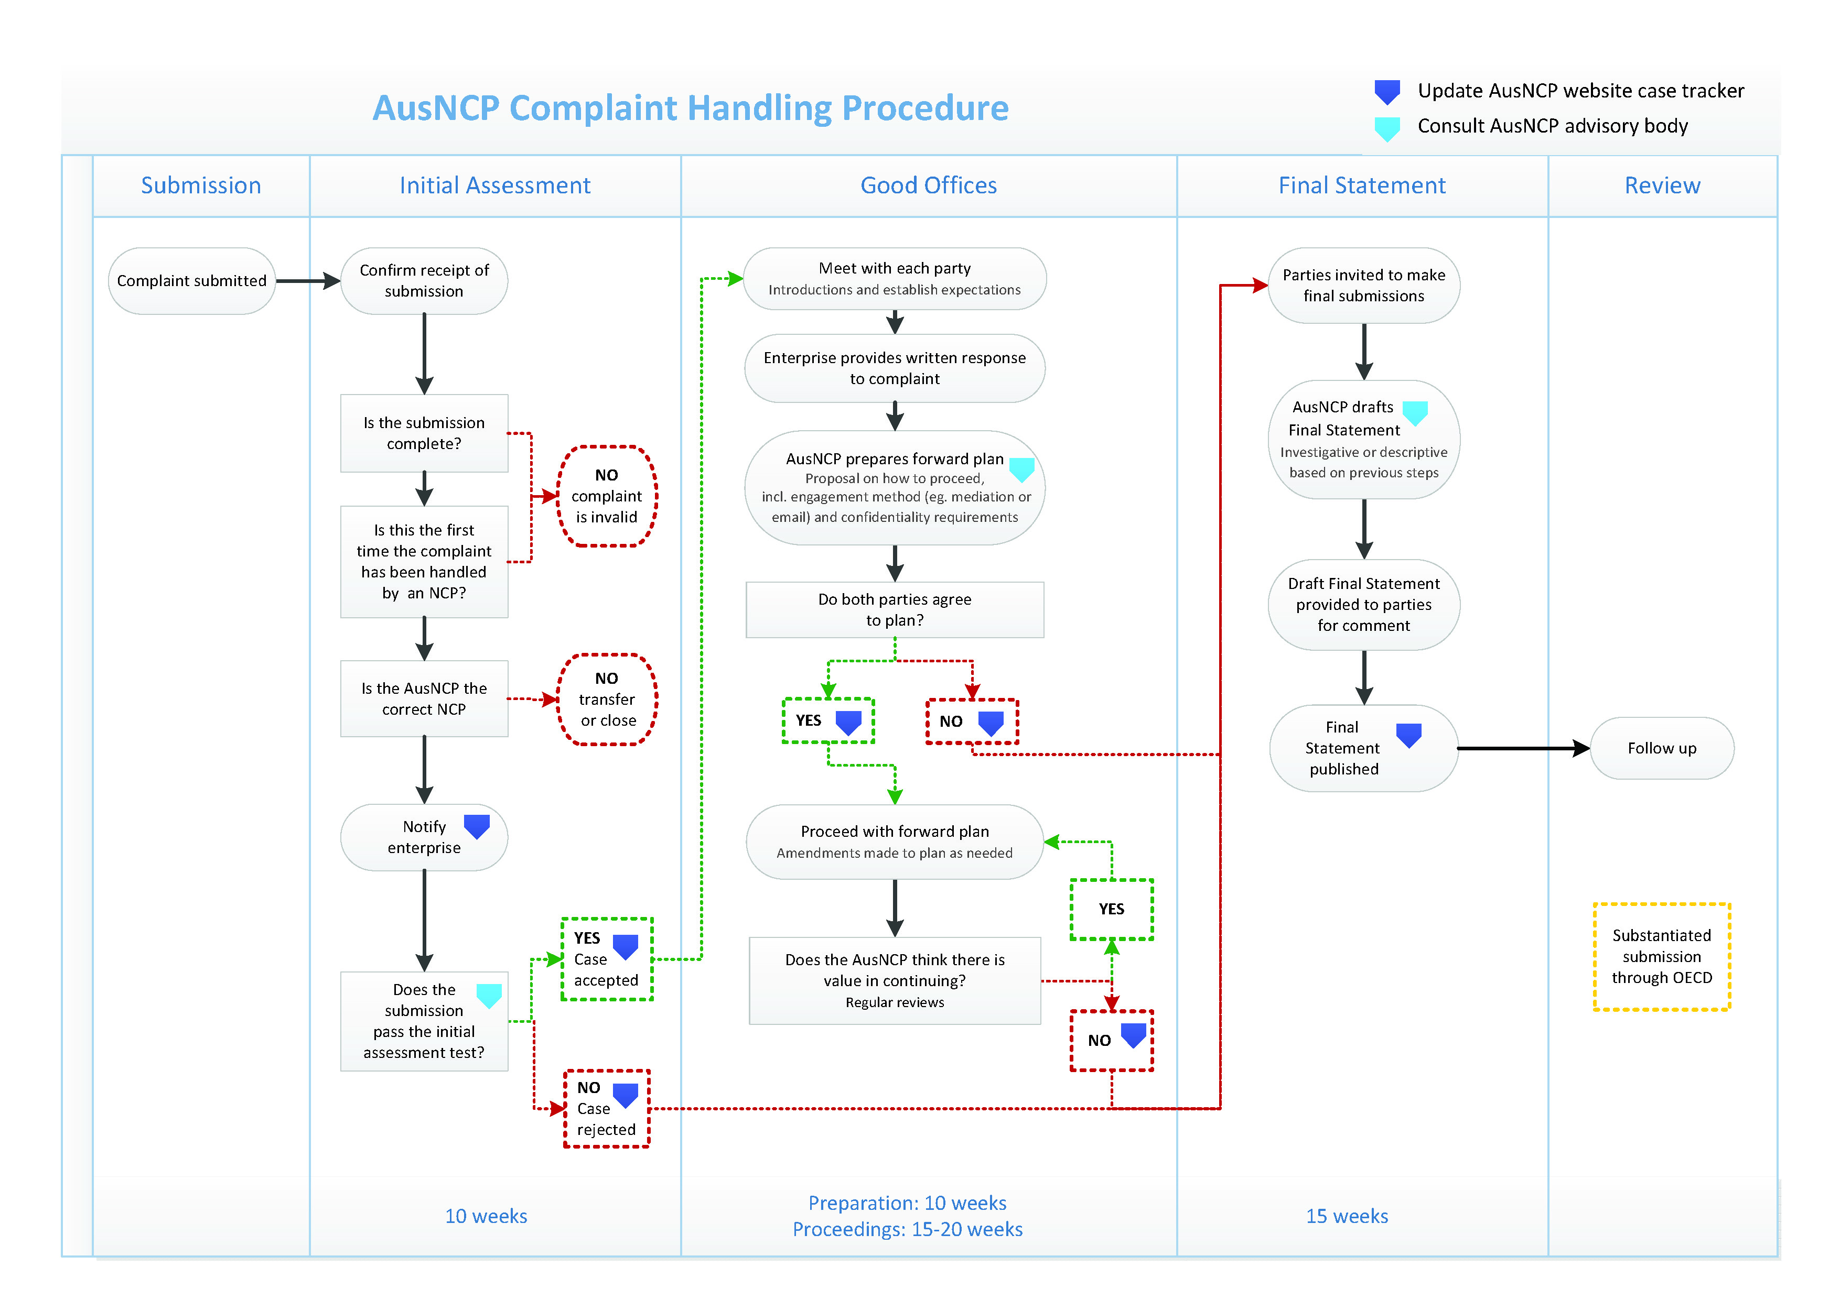
Appendix A — AusNCP specific instance procedures flowchart

OECD Guidelines for Multinational Enterprises, OECD 2011. Available at: http://www.oecd.org/daf/inv/mne/48004323.pdf
The AusNCP has recieved one request for review, however, this was not conducted by the Oversight Committee in line with published procedures. The Appeal Statement is available at: https://cdn.tspace.gov.au/uploads/sites/112/2018/02/ANCP_Appeal_statement_G4S_final.pdf
AusNCP Procedures, available at: https://ausncp.gov.au/specific-instances/complaints-procedures
NCP Mediation Manual, Consensus Building Institute July 2012. Available at: http://www.oecdguidelines.nl/binaries/oecd-guidelines/documents/leaflet/2015/1/6/ncp-mediation-
Consensus Building Institute, https://www.cbi.org/
Independent Review: Australian National Contact Point under the OECD Guidelines for Multinational Enterprises, available at: https://cdn.tspace.gov.au/uploads/sites/112/2018/02/Final-Report.pdf

