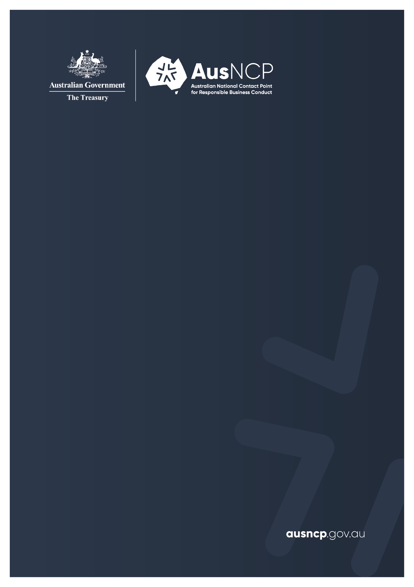

Final Statement

  - Complaint submitted by Marque Lawyers (on behalf of affected individuals) concerning Qatar Airways

15 September 2026

Disclaimer
The information contained within this document is intended to inform the reader of the general processes and undertakings arising from a specific instance complaint raised with the Australian National Contact Point for Responsible Business Conduct. It is made available on the understanding that the Australian Government Department of the Treasury, as a result of providing this information, is not engaged in providing professional or legal advice, nor does it accept any responsibility for the accuracy or completeness of any material contained herein. Readers should exercise their own judgement with respect to interpretation. This material includes the views of third parties, which do not necessarily reflect the views of the Commonwealth, or indicate its commitment to a particular course of action. Links to other websites and listings of other people or organisations are included for convenience and do not constitute endorsement of those sites, products, or services. The Australian Government respects the privacy of personal and commercially sensitive information provided by parties, as per the requirements of the Privacy Act 1988 and the Freedom of Information Act 1982.

© Commonwealth of Australia 2026
This publication is available for your use under a Creative Commons Attribution 4.0 International licence, with the exception of the Commonwealth Coat of Arms, the Treasury logo, photographs, images, third party materials, materials protected by a trademark, signatures and where otherwise stated. The full licence terms are available from creativecommons.org/licenses/by/4.0/legalcode.
Use of Treasury material under a Creative Commons Attribution 4.0 International licence requires you to attribute the work (but not in any way that suggests that the Treasury endorses you or your use of the work).
Treasury material used ‘as supplied’
Provided you have not modified or transformed Treasury material in any way including, for example, by changing the Treasury text; calculating percentage changes; graphing or charting data; or deriving new statistics from published Treasury statistics – then Treasury prefers the following attribution:
Source: The Commonwealth of Australia.
Derivative material
If you have modified or transformed Treasury material, or derived new material from those of the Treasury in any way, then Treasury prefers the following attribution:
Based on Commonwealth of Australia data.
Use of the Coat of Arms
The terms under which the Coat of Arms can be used are set out on the Department of the Prime Minister and Cabinet website (see www.pmc.gov.au/government/commonwealth-coat-arms).
Other uses
Enquiries regarding this licence and any other use of this document are welcome at:
Manager
Media Unit
The Treasury
Langton Crescent
Parkes ACT 2600
Email: media@treasury.gov.au
In the spirit of reconciliation, the Treasury acknowledges the Traditional Custodians of country throughout Australia and their connections to land, sea and community. We pay our respect to their Elders past and present and extend that respect to all Aboriginal and Torres Strait Islander peoples.

Contents
Executive summary 1
Final Statement 2
Parties 2
Complaint and outcomes sought by the notifier 2
AusNCP proceedings 2
Conclusion 4
Appendices 5
Appendix A: Schedule of events 5
Appendix B: Publications 7

Executive summary
In December 2021, the Australian National Contact Point for Responsible Business Conduct (AusNCP) received a received a complaint from Marque Lawyers (the notifier), on behalf of affected individuals (the complainants), concerning Qatar Airways Group (Q.C.S.C.) (the enterprise).
The complaint raised a number of allegations under the General Policies (Chapter II) and Human Rights (Chapter IV) chapters of the OECD Guidelines for Multinational Enterprises on Responsible Business Conduct (OECD Guidelines), in connection with events following the October 2020 discovery of a newborn baby at Hamad International Airport in Doha.
An Initial Assessment statement was published in August 2022, outlining the complaint and an AusNCP Independent Examiner’s decision to accept the matter for AusNCP-facilitated dispute resolution (or ‘good offices’, as it is referred to under the OECD Guidelines). The parties did not resolve the complaint through dispute resolution, and it therefore proceeded to an examination in accordance with the AusNCP complaint procedures.
After the AusNCP accepted the complaint, legal proceedings concerning the same events as those raised in the complaint were commenced in the Federal Court of Australia. The parties subsequently requested that the AusNCP suspend its examination, and the Independent Examiner agreed to do so.
In May 2026, the parties resolved the Federal Court of Australia proceedings by consent. Following this, the complainants requested the withdrawal of their AusNCP complaint.
In accordance with the AusNCP complaint procedures, the Independent Examiner made inquiries and was satisfied that the notifier had raised no concerns about reprisals against the complainants or risks to their safety. The enterprise was consulted on the proposed withdrawal, and this Final Statement was then prepared.
As the complaint was withdrawn before the examination resumed, the AusNCP has not made an assessment of whether the enterprise’s actions are consistent with the OECD Guidelines.
This statement is available on the AusNCP website at www.ausncp.gov.au.

John Southalan
Independent Examiner
Australian National Contact Point for Responsible Business Conduct
Email: secretariat@ausncp.gov.au

Final Statement

Parties
Marque Lawyers (an Australian law firm) submitted a complaint to the AusNCP on 10 December 2021 on behalf of the complainants, being seven women of varying ages and nationalities who requested not to be identified due to privacy concerns.
The complaint concerns Qatar Airways Group (Q.C.S.C.), an Australian-registered foreign company.

Complaint and outcomes sought by the notifier
The complaint related to events arising from the October 2020 discovery of a newborn baby at Hamad International Airport in Doha.
The complainants alleged that their human rights were violated when they were subjected to non-consensual physical examinations, and also in subsequent responses to their complaint to the enterprise about those events. The complainants alleged that these matters were inconsistent with the General Policies (Chapter II) and Human Rights (Chapter IV) chapters of the OECD Guidelines, and sought various remedial actions from the enterprise.

AusNCP proceedings
An AusNCP Independent Examiner conducted an Initial Assessment between December 2021 and August 2022 and decided that the complaint merited further consideration. An Initial Assessment statement accepting the complaint was published on the AusNCP website on 24 August 2022. The complaint was not subsequently resolved through AusNCP-facilitated dispute resolution (or ‘good offices’), and so proceeded to the examination stage in accordance with the AusNCP complaint procedures.
  - Preliminary discussions regarding the dispute resolution phase took place between Independent Examiner Shiv Martin and each individual party in September 2022. Correspondence between the parties and Independent Examiner Martin concerning dispute resolution preparation continued between 2022 and 2023, prior to the AusNCP process being suspended in September 2023.
After the complaint was accepted by the AusNCP, legal proceedings concerning the same events were commenced in the Federal Court of Australia. While the court proceedings were underway, the parties agreed that the AusNCP’s examination should be temporarily suspended. The AusNCP Independent Examiner agreed, and two Update Statements regarding the temporary suspension of the AusNCP process, including extensions of this suspension, were published on the AusNCP website in 2025.
On 7 May 2026, the Federal Court of Australia noted the parties had reached a settlement. On 28 May 2026, the Federal Court of Australia made orders by agreement between the parties. Arising from the resolution of the court proceedings, the notifier informed the AusNCP that the complainants wished to withdraw their AusNCP complaint.
The OECD Guidelines’ Implementation Procedures state that National Contact Points (NCPs) ‘are expected to always make the results of a specific instance publicly available’. In circumstances where a notifier withdraws from an NCP procedure, the relevant NCP should issue a public Final Statement describing the process followed to date.
  - The AusNCP complaint procedures also provide that, where a notifier seeks to withdraw their complaint, an Independent Examiner will:
    - consider whether there have been any concerns about reprisals or safety, including where appropriate by contacting the notifier or other relevant parties
    - consult the enterprise
    - where appropriate, close the complaint through the publication of a Final Statement.
- Consistent with the process described in paragraph 16.1 of this Final Statement, the Independent Examiner contacted the notifier, who informed the AusNCP that there had been no reprisals and raised no concerns about the safety of the complainants.
- The enterprise also raised no concerns about the complaint being withdrawn and closed in accordance with the process voluntarily requested by the notifier.
- As a result, the Independent Examiner prepared this Final Statement to finalise the withdrawal of the complaint.

Conclusion
The Independent Examiner notes that the complaint was withdrawn prior to any outcome of the AusNCP examination stage being reached, and that the parties have not informed the AusNCP of the details of any agreement or arrangement.
Given the notifier’s assurance that there are no concerns about reprisals against the complainants or risks to their safety, the Independent Examiner considers it appropriate to close the complaint by publishing a Final Statement, consistent with the complainants’ request to withdraw the complaint.
As the complaint was withdrawn before the AusNCP examined the matter, no assessment is made in this Final Statement as to whether the enterprise’s actions are consistent with the OECD Guidelines.
In preparing this Final Statement, the Independent Examiner consulted with the AusNCP Governance and Advisory Board (AusNCP Board) and considered all comments submitted by the parties on a draft version of this Final Statement.
This statement is available on the AusNCP website at www.ausncp.gov.au.

John Southalan
Independent Examiner
Australian National Contact Point for Responsible Business Conduct
Email: secretariat@ausncp.gov.au

Appendices

Appendix A: Schedule of events
Submission and Initial Assessment | Date
Notifier submitted complaint to the AusNCP via the webform | 10 December 2021
Receipt of submission acknowledged by the AusNCP Secretariat, and further information sought from the notifier | 14 December 2021
AusNCP Secretariat notified the AusNCP Board that a complaint had been allocated for an Initial Assessment | 14 December 2021
Enterprise notified that a complaint had been received and provided with copy of the complaint submission | 20 December 2021
Separate letters sent from the Independent Examiner to the parties to provide information about the complaint handling process and to seek further information for the purpose of deciding whether to accept the complaint | 2 February 2022
Submission from the enterprise received by the AusNCP Secretariat | 3 March 2022
Submission from the notifier received by the AusNCP Secretariat | 4 March 2022
Draft Initial Assessment statement provided to the AusNCP Board for comment | 19 April 2022
Draft Initial Assessment statement provided to the parties for comment | 31 May 2022
Enterprise submitted comments in response to draft Initial Assessment statement | 27 June 2022
Notifier submitted comments in response to draft Initial Assessment statement | 28 June 2022
Embargoed Initial Assessment statement provided to the parties | 10 August 2022
Embargoed Initial Assessment statement provided to the AusNCP Board | 12 August 2022
Initial Assessment statement published on AusNCP website (www.ausncp.gov.au) | 24 August 2022
Dispute resolution | Date
Independent Examiner Shiv Martin assigned to the ‘dispute resolution’ phase | 6 September 2022
Initial meeting held between Independent Examiner Martin and the enterprise regarding the dispute resolution phase | 12 September 2022
Initial meeting held between Independent Examiner Martin and the notifier regarding the dispute resolution phase | 13 September 2022
Correspondence from Independent Examiner Martin to the enterprise’s representatives regarding the complaint proceeding to examination and a Final Statement | 14 July 2023
Correspondence from Independent Examiner Martin to the notifier regarding the complaint proceeding to examination and a Final Statement | 21 July 2023
Examination | Date
Parties informed via letter that Independent Examiner John Southalan had been assigned to the ‘examination’ stage | 17 August 2023
Independent Examiner agreed to the parties’ request to suspend the examination of the complaint | 26 September 2023
Parties advised that the examination of the complaint would remain suspended for six months due to parallel proceedings | 8 April 2024
Parties agreed to a further six-month suspension due to parallel proceedings, and a draft Update Statement was provided to the parties for comment | 12 December 2024
Update Statement, suspending examination of the complaint until June 2025, published on AusNCP website (www.ausncp.gov.au) | 13 January 2025
Parties agreed to an additional three-month suspension of the AusNCP process due to parallel proceedings continuing | 13 June 2025
Draft Update Statement provided to the parties for comment | 2 October 2025
Further Update Statement, suspending examination of the complaint until April 2026, published on AusNCP website (www.ausncp.gov.au) | 9 October 2025
The notifier informs the AusNCP that the complainants wish to withdraw their AusNCP complaint | 28 May 2026
Final Statement | Date
Draft Final Statement provided to the AusNCP Board for comment | 1 July 2026
Draft Final Statement provided to the parties for comment | 31 July 2026
Embargoed copy of Final Statement provided to the parties and the AusNCP Board ahead of publication | 1 September 2026
Final Statement published on www.ausncp.gov.au and reported to the OECD Database of Specific Instances | 15 September 2026

Appendix B: Publications
Australian National Contact Point for Responsible Business Conduct, ‘Complaint submitted by Marque Lawyers (on behalf of affected individuals) regarding Qatar Airways’, Initial Assessment, Department of the Treasury, Australian Government, Canberra, 24 August 2022. https://ausncp.gov.au/sites/default/files/2022-08/30-ausncp-initial-assessment.pdf
Australian National Contact Point for Responsible Business Conduct, ‘AusNCP complaint procedures’, Department of the Treasury, Australian Government, Canberra, April 2024. https://ausncp.gov.au/sites/default/files/2024-04/ausncp-complaint-procedures.pdf
Australian National Contact Point for Responsible Business Conduct, ‘Complaint submitted by Marque Lawyers (on behalf of affected individuals) regarding Qatar Airways’, Update Statement, Department of the Treasury, Australian Government, Canberra, 13 January 2025. https://ausncp.gov.au/sites/default/files/2025-01/30-ausncp-update-statement-jan-2025.pdf
Australian National Contact Point for Responsible Business Conduct, ‘Complaint submitted by Marque Lawyers (on behalf of affected individuals) regarding Qatar Airways’, Update Statement, Department of the Treasury, Australian Government, Canberra, 9 October 2025. https://ausncp.gov.au/sites/default/files/2025-10/30-ausncp-update-statement-oct-2025.pdf
Federal Court of Australia, DHI22 v Qatar Airway Group QCSC, Directions Order, 7 May 2026. https://www.comcourts.gov.au/file/Federal/P/NSD837/2022/3944782/event/32858044/document/2766741
Federal Court of Australia, DHI22 v Qatar Airway Group QCSC, Consent Order, 28 May 2026. https://www.comcourts.gov.au/file/Federal/P/NSD837/2022/3944782/event/32909416/document/2785546
Organisation for Economic Co-operation and Development, ‘OECD Guidelines for Multinational Enterprises on Responsible Business Conduct’, OECD Publishing, Paris, 8 June 2023. http://dx.doi.org/10.1787/81f92357-en

Australian National Contact Point for Responsible Business Conduct (AusNCP), Initial Assessment: Complaint submitted by Marque Lawyers (on behalf of affected individuals) regarding Qatar Airways, 24 August 2022.
AusNCP, AusNCP complaint procedures, April 2024, p 11 [51].
AusNCP, AusNCP complaint procedures, p 16 [99].
Initial Assessment: Complaint submitted by Marque Lawyers (on behalf of affected individuals) regarding Qatar Airways.
AusNCP complaint procedures, p 11 [51].
AusNCP, Update Statement on complaint submitted by Marque Lawyers (on behalf of affected individuals) regarding Qatar Airways, 13 January 2025; AusNCP, Update Statement on complaint submitted by Marque Lawyers (on behalf of affected individuals) regarding Qatar Airways, 9 October 2025.
Per the Federal Court of Australia’s public record in DHI22 and others -v- Qatar Airways Group QCSC and others (Federal Court No: NSD837/2022, Justice Halley, 7 May 2026, Note A).
The Federal Court of Australia’s public records show consent orders that the proceedings be dismissed with no costs orders: DHI22 and others -v- Qatar Airways Group QCSC and others (Federal Court No: NSD837/2022, Justice Halley, 28 May 2026).
Organisation for Economic Co-operation and Development (OECD), OECD Guidelines for Multinational Enterprises on Responsible Business Conduct, OECD Publishing, 8 June 2023 (OECD Guidelines), p 71 [39].
AusNCP, AusNCP complaint procedures, p 16 [99].

