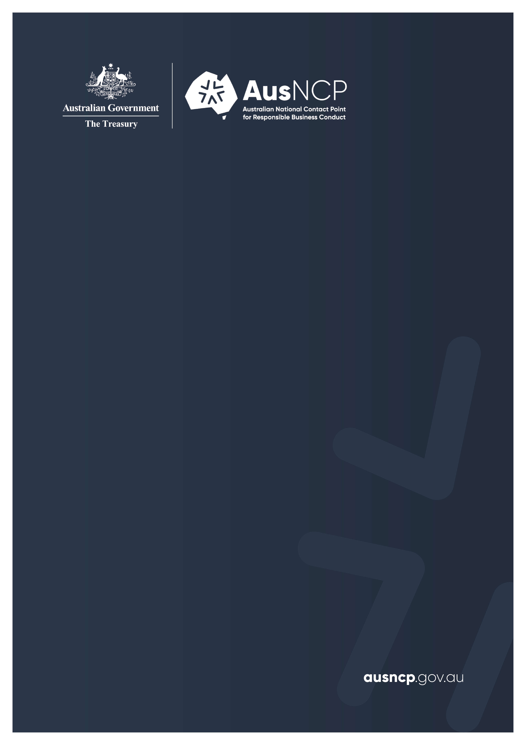

Transfer Statement

Disclaimer
The information contained within this document is intended to inform the reader of the general processes and undertakings arising from a specific instance complaint raised with the Australian National Contact Point for Responsible Business Conduct. It is made available on the understanding that the Australian Treasury, as a result of providing this information, is not engaged in providing professional or legal advice, nor does it accept any responsibility for the accuracy or completeness of any material contained herein. Readers should exercise their own judgement with respect to interpretation. This material includes the views of third parties, which do not necessarily reflect the views of the Commonwealth, or indicate its commitment to a particular course of action. Links to other websites and listings of other people or organisations are included for convenience and do not constitute endorsement of those sites, products or services. The Commonwealth Government respects the privacy of personal and commercially sensitive information provided by parties, as per the requirements of the Privacy Act 1988 and the Freedom of Information Act 1982.

  - Complaint submitted by an individual about an Australian multinational enterprise in the mining and quarrying sector

19 March 2026
© Commonwealth of Australia 2026
This publication is available for your use under a Creative Commons Attribution 3.0 Australia licence, with the exception of the Commonwealth Coat of Arms, the Treasury logo, photographs, images, signatures and where otherwise stated. The full licence terms are available from http://creativecommons.org/licenses/by/3.0/au/legalcode.
Use of Treasury material under a Creative Commons Attribution 3.0 Australia licence requires you to attribute the work (but not in any way that suggests that the Treasury endorses you or your use of the work).
Treasury material used ‘as supplied’
Provided you have not modified or transformed Treasury material in any way including, for example, by changing the Treasury text; calculating percentage changes; graphing or charting data; or deriving new statistics from published Treasury statistics — then Treasury prefers the following attribution:
Source: The Australian Government the Treasury
Derivative material
If you have modified or transformed Treasury material, or derived new material from those of the Treasury in any way, then Treasury prefers the following attribution:
Based on The Australian Government the Treasury data
Use of the Coat of Arms
The terms under which the Coat of Arms can be used are set out on the Department of the Prime Minister and Cabinet website (see www.pmc.gov.au/government/commonwealth-coat-arms).
Other uses
Enquiries regarding this licence and any other use of this document are welcome at:
Manager
Media Unit
The Treasury
Langton Crescent
Parkes ACT 2600
Email: media@treasury.gov.au

Contents
Transfer Statement 1
Annexes 3
Annex A: Publications 3
Annex B: Institutional arrangements 4
Annex C: Governance 5

Transfer Statement
- On 9 October 2025, the Australian National Contact Point for Responsible Business Conduct (AusNCP) received a complaint about activities undertaken by a Chilean subsidiary of an Australian-based multinational enterprise operating in the mining and quarrying sector.
- The notifier (a Chilean national) alleged in the complaint that certain conduct by the subsidiary and the multinational enterprise was inconsistent with the OECD Guidelines for Multinational Enterprises on Responsible Business Conduct (OECD Guidelines).
- An AusNCP Independent Examiner was appointed to handle this complaint in October 2025, at which point a coordination process commenced to identify a lead National Contact Point (NCP).
- The OECD Guidelines specify that ‘the NCP of the country in which the issues have arisen [will generally] be the lead NCP’ for a submitted NCP complaint. The AusNCP complaint procedures also provide that an Independent Examiner may seek to transfer a complaint received by the AusNCP to another NCP during the Initial Assessment phase, but only after:
  - first consulting with the AusNCP Governance and Advisory Board (AusNCP Board), the notifier and the enterprise
  - subsequently publishing a Transfer Statement on the AusNCP website to explain the reasons for the transfer and to identify the NCP that is receiving the complaint.
- Due to the complaint’s connection to Chile, the Independent Examiner considered the potential transfer of the complaint to the Chilean NCP. The AusNCP consulted with the Chilean NCP on whether it should be the lead NCP for this matter, with the AusNCP to provide support if necessary and as requested by the Chilean NCP. The Chilean NCP confirmed, in January 2026, that it would accept a transfer of the complaint.
- The AusNCP then consulted with the parties, who agreed with the Independent Examiner’s proposed transfer to the Chilean NCP for an Initial Assessment to take place, noting that:
  - the alleged issues have arisen in Chile and concern the Chilean subsidiary of a multinational enterprise, whose staff are native Spanish speakers
  - the complaint appears to relate to parallel legal proceedings within Chile
  - any future potential mediation, and the exploration and development of remediation solutions with the parties, would be more appropriately conducted by the Chilean NCP
  - the notifier is a Chilean national and has not raised any exceptional circumstances for the AusNCP to continue handling this complaint.
- Considering the reasons outlined above, together with the Chilean NCP’s agreement to a transfer in this instance, the Independent Examiner has decided that this complaint should be transferred to the Chilean NCP. The AusNCP remains available to assist the Chilean NCP should any support be required during its Initial Assessment process or in resolving the complaint during subsequent stages, if applicable.
- The Chilean NCP provided an explanation of its relevant process and requested that this information be included in this statement:
Under the Rules of Procedure of the Chilean NCP, once the Transfer Statement has been published, the notifier will re-submit the complaint to the Chilean NCP, through one of the channels below, to formalise that the Chilean NCP will lead the handling of the complaint:
Online submission: By completing and submitting the complaint through the Chilean NCP’s online web form.
Correspondence Office: By downloading, completing and sending a specific instance request form to the Chilean NCP through the Correspondence Office of the Undersecretariat of International Economic Affairs (SUBREI), located at Teatinos 180, Santiago, Chile; or by emailing the completed and printed form to the Chilean NCP, which will subsequently process the submission through SUBREI’s Correspondence Office.
- The AusNCP notes that this transfer was not based on the merits of the claims presented, nor on any assessment of whether the enterprise or its subsidiary have acted consistently with the OECD Guidelines. Importantly, the expectations of the OECD Guidelines remain unchanged, notwithstanding that a different NCP will now be the lead NCP for this complaint.
- This Transfer Statement does not identify either party. However, should the Chilean NCP publish the identity of the enterprise following the transfer of this complaint, the AusNCP will update the complaint’s details on its website to also include the name of the enterprise.
- This statement is available on the AusNCP website at www.ausncp.gov.au.

John Southalan
Independent Examiner
Australian National Contact Point for Responsible Business Conduct
Email: secretariat@ausncp.gov.au

Annexes

Annex A: Publications
Australian National Contact Point for Responsible Business Conduct, ‘AusNCP complaint procedures’, Australian Government, April 2024, accessed January 2026. https://ausncp.gov.au/sites/default/files/2024-04/ausncp-complaint-procedures.pdf
National Contact Point of Chile for Responsible Business Conduct, ‘Rules of Procedure for the Handling of Specific Instances of the National Contact Point of Chile’, Undersecretariat of International Economic Affairs, Ministry of Foreign Affairs of Chile, August 2025, accessed January 2026.
https://www.subrei.gob.cl/docs/default-source/default-document-library/202004-16-reglas-de-procedimiento_instancias-espec%C3%ADficas_pnc_chile.pdf?sfvrsn=e36bdae2_6
National Contact Point of Chile for Responsible Business Conduct, ‘Completed Instances’, Undersecretariat of International Economic Affairs, Ministry of Foreign Affairs of Chile, n.d., accessed January 2026.
https://www.subrei.gob.cl/ejes-de-trabajo/cer/punto-nacional-de-contacto/instancias/concluidas
National Contact Point of Chile for Responsible Business Conduct, ‘Instances – Ongoing’, Undersecretariat of International Economic Affairs, Ministry of Foreign Affairs of Chile, n.d., accessed January 2026.
https://www.subrei.gob.cl/ejes-de-trabajo/cer/punto-nacional-de-contacto/instancias/en-curso
National Contact Point of Chile for Responsible Business Conduct, ‘Specific Instance Request Form before the National Contact Point’, Undersecretariat of International Economic Affairs, Ministry of Foreign Affairs of Chile, n.d., accessed January 2026.
https://www.subrei.gob.cl/docs/default-source/punto-nacional-de-contacto/formulario-de-descarga-para-correo-postal.pdf?sfvrsn=77856609_2
Organisation for Economic Co-operation and Development, OECD Guidelines for Multinational Enterprises on Responsible Business Conduct, OECD Publishing, 8 June 2023, accessed January 2026. http://dx.doi.org/10.1787/81f92357-en

Annex B: Institutional arrangements
- The Australian Government is committed to promoting the use of the OECD Guidelines and implementing them effectively and consistently. Through business cooperation and support, the OECD Guidelines can positively influence business conduct and ultimately economic, environmental and social progress.
- The OECD Guidelines are recommendations on responsible business conduct addressed by governments, including Australia, to multinational enterprises. They provide voluntary principles and standards for responsible business conduct consistent with applicable laws and internationally recognised standards. Enterprises operating in Australia and Australian enterprises operating overseas are expected to act in accordance with the principles set out in the OECD Guidelines and to perform to the standards they recommend. In countries where domestic laws and regulations conflict with the principles and standards of the OECD Guidelines, enterprises should seek ways to honour such principles and standards to the fullest extent, which does not place them in violation of domestic law.
- The OECD Guidelines represent international standards of behaviour, which in some areas, may impose higher standards than Australian law. Importantly however, while Australia is an adhering country to the OECD Guidelines and the OECD Guidelines have been endorsed within the OECD international forum, they are not a substitute for, nor do they override, Australian or international law.
- The OECD Guidelines can be seen as:
  - A useful aid to business in developing their own code of conduct. They are not aimed at replacing or preventing enterprises from developing their own codes.
  - Complementary to other business, national and international initiatives on corporate responsibility, including domestic and international law in specific areas such as human rights and bribery. For example, the human rights chapter in the OECD Guidelines as well as other key concepts align with the United Nations Guiding Principles on Business and Human Rights.
  - Providing an informal structure for resolving issues that may arise in relation to implementation of the OECD Guidelines in complaints.

Annex C: Governance
- Governments adhering to the OECD Guidelines have flexibility in organising their NCPs, which are expected to meet core effectiveness criteria, by operating in a manner that is visible, accessible, transparent, accountable, impartial and equitable, predictable, and compatible with the OECD Guidelines. NCPs are also expected to seek the active support of social partners, other stakeholders and relevant government agencies.
- Accordingly, the OECD Guidelines stipulate that:
  - NCPs will be composed, organised and sufficiently resourced to provide an effective basis for dealing with the broad range of issues covered by the OECD Guidelines, have access to expertise on all relevant aspects of the NCP mandate, and operate in an impartial manner and maintain an adequate level of accountability to the adhering government.
  - NCPs can use different forms of organisation to meet the effectiveness criteria and maintain stakeholder confidence.
  - Governments are encouraged to include representatives of the business community, worker organisations, civil society and other non-governmental organisations in advisory or oversight bodies to assist the NCP in its tasks and contribute to the effectiveness of the OECD Guidelines.
- The AusNCP Board includes representatives from Australian Government agencies, business, civil society and unions. The AusNCP Board provides independent expert advice and assistance to the AusNCP and the Independent Examiners on complaints handling. Board members use their networks, events and publications to promote responsible business conduct standards under the OECD Guidelines and the AusNCP services. The AusNCP Board is consulted on all AusNCP statements.
- The AusNCP Board helps to ensure that the AusNCP meets the effectiveness criteria of the OECD Guidelines. AusNCP Board Members may be called on to conduct procedural reviews of AusNCP complaints and may be consulted on various operational and administrative matters as needed.

Organisation for Economic Co-operation and Development (OECD), OECD Guidelines for Multinational Enterprises on Responsible Business Conduct I. Commentary on the Procedures for NCPs, OECD Publishing, 8 June 2023, doi: 10.1787/81f92357-en., para [30], p 69 (OECD Guidelines).
Australian National Contact Point for Responsible Business Conduct (AusNCP), AusNCP complaint procedures, April 2024, para [24].
AusNCP complaint procedures, para [26]. See, also, OECD Guidelines, I. Commentary on the Procedures for NCPs, para [30].
AusNCP complaint procedures, paras [32] and [35].
As is permissible for both ongoing and completed Chilean National Contact Point specific instances. The Chilean National Contact Point, under its Rules of Procedure (p 11), may also draft statements in a way that protects the identity of one or more parties.
In line with the intent of para [35] of the AusNCP complaint procedures.

